🟢 Bandit Level 6 → Level 7
After logging in as bandit6, the password is somewhere on the server.
The clues are:
- Owned by user bandit7
- Owned by group bandit6
- Exactly 33 bytes
✅ Find the file
Run:
find / -user bandit7 -group bandit6 -size 33c 2>/dev/null
You should get a path similar to:
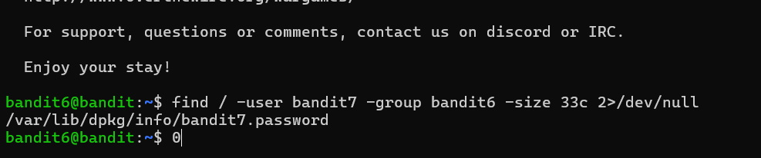
You should get a path similar to:
/var/lib/dpkg/info/bandit7.password
Then read it:
cat /var/lib/dpkg/info/bandit7.password
🔑 The output is the password for bandit7 Bmnnvf82KzQlfxgAI2d1zYbr1u9pr3E3

